|  |
| --- |
| NLX Options  Pricing & Risk Management Methodology |

October 2015

Document History

|  |  |  |  |
| --- | --- | --- | --- |
| **Date** | **Version** | **Author** | **Summary of Changes** |
| 29th August 2014 | 1.0 | Paul Savage | Original draft |
| 2nd March 2015 | 1.1 | Paul Savage | Amendments to sections 2.3 and 2.4 in order to reflect the fact that – owing to the possibility / actuality of negative interest rates – STIR future options will be priced using the ***normal*** (as opposed to log-normal) version of the Asay-82 model |
| 30th Sep 2015 | 1.2 | Rickinder Singh | Updated DMP, Operational Procedures sections |
| 05 October 2015 | 1.3 | Rickinder Singh | Incorporating Feedback from David Horner |
| 05 October 2015 | 1.4 | Vinit Thakkar | Updated & re-organised stress testing |
| 05 October 2015 | 1.5 | Peter Jurcaga | Updated Backtesting section |
| 05 October 2015 | 1.6 | Bobby Damghani | Sections added to account for the skew add-on methodology |
| 14 October 2015 | 1.7 | Denis Papaioannou | Updated |
| 15 October 2015 | 1.8 | Felipe San Blas | Updated add-on methodology |
| 19 October 2015 | 1.9 | Rickinder Singh | Updated the document with Model Validation findings |
| 20 October 2015 | 1.10 | Vinit Thakkar | Updated section 8.6 - Testing |
| 20 October 2015 | 1.11 | Peter Jurcaga | Updated section 5.6 – Back-Testing and added appendix 3 |
| 29 October 2015 | 1.12 | Felipe San Blas | Updated results in sections 6 and 7 |

Table of Contents

Document History 2

Abbreviations 5

Introduction 6

Background 6

Purpose of the Document 6

1 Overview of NLX Initial Margin Methodology 7

1.1 Product Coverage 7

1.2 Pricing Methodologies 7

1.3 Relevant Risk Factors 8

1.4 Look-Back Period 10

1.5 Historic Risk Factor Returns 10

1.6 Historic Volatility 11

1.7 Re-Scaled Returns 11

1.8 Simulated Risk Factors 12

1.9 Simulated P&L 12

1.10 Initial Margin Estimation 13

1.11 Pro-Cyclicality Buffer 13

1.12 Initial Margin Floor 14

1.13 Model Add-ons 14

2 Pricing Methodologies 15

2.1 STIR Futures 15

2.2 Government Bond Futures 16

2.3 Options on STIR Futures 20

2.4 Options on Government Bond Futures 21

3 Implied Volatility Related Methodologies 23

3.1 Implied Volatility Surface Construction 23

3.2 Option Pricing - Implied Volatility Interpolation 25

3.3 ATM Implied Volatility Historic Time Series 25

3.4 HVAR Simulation 25

3.5 Skew Methodology for Stress Scenarios 27

3.6 Liquidity Methodology 27

4 Pricing Data / Assumptions 32

4.1 STIR Futures 32

4.2 Government Bond Futures 32

4.3 Options on STIR Futures 33

4.4 Options on Government Bond Futures 34

5 Default Management Process 35

5.1 Interaction with portfolio margining 35

5.2 Management information 35

5.3 Determination of close-out strategy 35

6 Back-testing of Initial Margin 36

6.1 Scope and Approach 36

6.2 Market Data and Portfolios 37

6.3 Results 37

6.4 Conclusion 39

6.5 Independent Validation 39

7 Model Add-ons 40

7.1 Volatility Model 40

7.2 Volatility Add-on 40

7.3 Volatility add-on scenarios 43

7.4 Theta Add-on 43

7.5 Add-on Analysis and Results 43

7.6 Independent Validation 44

8 Stress Testing 45

8.1 Preliminary analysis 45

8.2 Methodology – Historical ATM Options 45

8.3 Results – ATM 45

8.4 Methodology – Theoretical 45

8.5 Proposed scenarios 46

8.6 Testing 46

8.7 Independent Validation 46

9 Reporting 48

9.1 Theoretical Prices vs. Actual Prices 48

9.2 Cheapest-to-Deliver Bond Spreads 48

9.3 Sensitivity Analysis 49

10 Operational Procedures 50

Appendix 1 – Fitted Volatility Smile Model 51

Model Formulation 51

Market Data 51

Example of FVS Parameterisation 51

Appendix 2 – Formulation of Asay Model “Greeks” 53

• Delta 53

• Gamma 53

• Vega 53

• Theta 53

Appendix 3 – Back-test Results – Options on EURIBOR STIRS – Theoretical ATM contracts. 54

Appendix 4 – Stress Testing Results 56

Abbreviations

**ATM** - At-the-Money

**CCP** - Central Counterparty

**CTD** - Cheapest-to-Deliver

**EMIR** - European Market Infrastructure Regulation

**ESMA** - European Securities and Markets Authority

**EWMA** - Exponentially Weighted Moving Average

**FRA** - Forward Rate Agreement

**FVS** - Fitted Volatility Smile

**GC** - General Collateral

**HVAR** - Historic Value-at-Risk

**IM** - Initial Margin

**IRS** - Interest Rate Swap

**LCHC** - LCH.Clearnet Group Limited

**PAIRS** - Portfolio Approach to Interest Rate Scenarios

**STIR** - Short Term Interest Rate

**SVI** - Stochastic Volatility Inspired

Introduction

Background

In order to complement its existing fixed income derivatives offering, NLX is planning to launch various series of exchange-traded options on short-term interest rate (STIR) futures and government bond futures.

Purpose of the Document

The purpose of this document is to articulate both the ***pricing*** and ***initial margin*** (IM) methodologies for the aforementioned categories of options, and thereby act as a technical reference point in this regard.

For completeness and in order to provide relevant context / background, the document also includes a description of the corresponding methodologies for the underlying futures themselves.

The document also includes a description of the proposed default management procedures and the scenarios framework that will be used to size the default fund.

# Overview of NLX Initial Margin Methodology

The Listed Rates default fund covers a range of listed interest rate derivative products that are cleared by LCH.Clearnet Group Limited (LCHC) as part of its NLX service.

It is proposed to include NLX’s option-based products in the same default fund and, in so doing, adopt the same general approach to pricing ***and*** the wider specifics of the IM methodology that underpin the existing (NLX) service.

This section describes the existing NLX IM methodology – based on an historic value-at-risk (HVAR) simulation and forming part of LCHC’s harmonised Portfolio Approach to Interest Rate Scenarios (PAIRS) model – ***as adapted*** (where applicable) to accommodate options.

## Product Coverage

The existing NLX service covers the following products:

* 3-Month EURIBOR Futures
* 3-Month Short Sterling Futures
* Long Gilt Futures
* Euro-Schatz Futures
* Euro-Bobl Futures
* Euro-Bund Futures

The products listed above clearly fall into two distinct categories, namely STIR futures and government bond futures.

It is proposed to incorporate the following 7 option series into the service:

* Options on 3-Month EURIBOR Futures
* 1/2/3/4 Year Mid-Curve Options on 3-Month EURIBOR Futures
* Options on 3-Month Short Sterling Futures
* 1/2/3/4 Year Mid-Curve Options on 3-Month Short Sterling Futures
* Options on Euro-Schatz Futures
* Options on Euro-Bobl Futures
* Options on Euro-Bund Futures

For completeness, ***all*** of the products listed above (i.e. futures ***and*** options) are covered in this document (where relevant), notably in the detailed section on Pricing Methodologies.

## Pricing Methodologies

Underlying LCHC’s approach to pricing the various products listed in section 1.1 above is the principle of ***forward pricing***.

Specifically, STIR futures are priced in accordance with the relevant underlying forward interest rate and government bond futures are priced in accordance with the relevant underlying cheapest-to-deliver (CTD) bond i.e. as evaluated on a forward basis.

These forward-based prices for futures are also used to price the various series of options thereon (in conjunction with the relevant implied volatility surface for each series).

Pursuant to the above, each class of product has a specific (closed-form) pricing function. These are covered in section 2 below.

## Relevant Risk Factors

The risk factors underlying the NLX IM model fall into 5 broad categories as follows:

* Index Curves
* Sovereign Discount Curves
* Repo / General Collateral (GC) Curves
* Implied Volatility Surfaces
* Foreign Exchange Rates

The index curves are used to estimate / project forward interest rates, which are in turn used to price the range of 3-month STIR futures as well as the various options thereon.

The sovereign discount and repo / GC curves are used to forward-price the various CTD bonds that underlie the range of government bond future and bond future option contracts.

The implied volatility surfaces are used to price the various option-based products, and the foreign exchange rates are used to translate any non-GBP denominated P&L vectors (generated as part of the HVAR simulation) into “base” currency equivalents.

### Index Curves

In keeping with the contracts that they are ultimately used to price, the index curves for EUR and GBP are each bootstrapped using a strip of STIR futures prices (i.e. as opposed to the LIBOR, forward-rate agreement (FRA) and interest rate swap (IRS) rates that are used to generate forward rate-setting curves for interest rate swaps in SwapClear).

For the same reason, no convexity adjustment is made in this particular bootstrapping process.

The complete list of index curves and underlying tenor points is as follows:

|  |  |
| --- | --- |
| **Risk Factor** | **Tenors** |
| EUR CASH | 24 quarterly time buckets spanning 6 years  i.e. 3M, 6M, 9M, 1Y ... 6Y at 3M intervals |
| GBP CASH | 24 quarterly time buckets spanning 6 years  i.e. 3M, 6M, 9M, 1Y ... 6Y at 3M intervals |

These curves are composed of ***annually*** compounded zero-coupon rates and use an ***Actual/365*** day basis.

### Sovereign Discount Curves

The zero-coupon sovereign discount curves are consistent with those used in the RepoClear service and are as follows:

|  |  |
| --- | --- |
| **Risk Factor** | **Tenors** |
| EUR BOND DE I016 | 18 time buckets spanning 30 years  i.e. 1D, 1W, 1M, 3M, 6M, 1Y ... 10Y at annual intervals, 15Y, 20Y and 30Y |
| GBP BOND GB I022 | 18 time buckets spanning 30 years  i.e. 1D, 1W, 1M, 3M, 6M, 1Y ... 10Y at annual intervals, 15Y, 20Y and 30Y |

As above, these curves are composed of ***annually*** compounded zero-coupon rates and use an ***Actual/365*** day basis.

### Repo / General Collateral Curves

In the existing NLX IM model, only the ***current*** repo rate for each government bond future’s CTD is used i.e. in order to derive the prevailing theoretical forward price thereof in accordance with the methodology described in section 2.2 below.

These rates are expressed as ***annually*** compounded zero-coupon rates and use an ***Actual/365*** day basis.

### Implied Volatility Surfaces

Each of the 7 (in-scope) option series listed in section 1.1 above is priced using a ***distinct*** implied volatility surface, specifically constructed for the purpose using a suitable range of exchange-published prices.

On any given day, each surface is ***initially*** defined by a series of fitted implied volatility ***curves***, one for each expiry tenor. Each such curve is parameterised using a methodology akin to LCHC’s own Fitted Volatility Smile (FVS) model, the details of which are reproduced in Appendix 1.

The fitted implied volatility curve for each expiry tenor is then re-fitted from its original array of ***actual*** (i.e. strike-specific) “moneyness” pillars to pre-determined set of ***standard*** equivalents. For this purpose, moneyness is measured as the natural log of the option strike divided by the corresponding futures price.

Thereafter, the intermediate implied volatility surface above is re-fitted once more, this time to a pre-determined set of standard expiry tenors.

The precise methodological details of these re-fitting steps are described in the section on Implied Volatility Related Methodologies below (section 3).

Using a fitted implied volatility surface to price each series of options serves the following purposes:

* It facilitates the estimation of an at-the-money (ATM) implied volatility for each standard expiry tenor, as defined below for each option series. Historic movements in these various *n*-day ATM implied volatility levels form the basis of the HVAR simulation (see section 3 below for further details).
* In addition, it allows the pricing effect of the implied volatility smile to be captured in the HVAR simulation. In other words – for any particular option – it provides a means of imputing the change in implied volatility level that arises as a result of a given (simulated) change in the price of the underlying future. In the HVAR simulation, this moneyness effect is combined with that arising from changes in the general ***level*** and ***shape*** of each implied volatility surface. These changes are brought about by shifting each standard expiry tenor “slice” of the implied volatility surface in accordance with the simulated returns generated for the corresponding *n*-day ATM implied volatility level above.

In summary, each of the 7 distinct option series listed in section 1.1 above uses the following implied volatility risk factors:

|  |  |
| --- | --- |
| **Pricing / Smile Element of HVAR Simulation** | **Volatility Level Element of HVAR Simulation** |
| ***Current*** fitted implied volatility surface, each point thereon corresponding to a particular combination of option moneyness – measured as the natural log of the option strike divided by the corresponding futures price – and expiry tenor | ***Historic*** series of *n*-day ATM implied volatility levels, with each corresponding set of (scaled) returns being applied to the entire *n*-day (i.e. standard expiry tenor) “slice” of the current fitted implied volatility surface |

On each particular day, the set of moneyness pillars for each option series will depend on the range of available exchange-published option prices. As a result, it follows that this particular dimension of each implied volatility surface is ***flexible*** and therefore subject to change, potentially on a daily basis.

The complete list of standard expiry tenor points is as follows:

|  |  |
| --- | --- |
| **Option Series** | **Tenors** |
| EURIBOR | 15 time buckets spanning 730 days  i.e. 1D, 7D, 14D, 21D, 30D, 60D, 90D, 120D, 180D, 270D, 365D, 455D, 535D, 625D, 730D |
| EURIBOR  1/2/3/4 Year Mid-Curve | 15 time buckets spanning 730 days  i.e. 1D, 7D, 14D, 21D, 30D, 60D, 90D, 120D, 180D, 270D, 365D, 455D, 535D, 625D, 730D |
| Short Sterling | 15 time buckets spanning 730 days  i.e. 1D, 7D, 14D, 21D, 30D, 60D, 90D, 120D, 180D, 270D, 365D, 455D, 535D, 625D, 730D |
| Short Sterling  1/2/3/4 Year Mid-Curve | 15 time buckets spanning 730 days  i.e. 1D, 7D, 14D, 21D, 30D, 60D, 90D, 120D, 180D, 270D, 365D, 455D, 535D, 625D, 730D |
| Euro-Schatz | 10 time buckets spanning 365 days  i.e. 1D, 7D, 14D, 21D, 30D, 60D, 90D, 120D, 180D, 365D |
| Euro-Bobl | 10 time buckets spanning 365 days  i.e. 1D, 7D, 14D, 21D, 30D, 60D, 90D, 120D, 180D, 365D |
| Euro-Bund | 10 time buckets spanning 365 days  i.e. 1D, 7D, 14D, 21D, 30D, 60D, 90D, 120D, 180D, 365D |

### Foreign Exchange Rates

The foreign exchange rates are consistent with those used in SwapClear, i.e. the relevant spot FX rate vs GBP.

## Look-Back Period

The look-back period for the NLX HVAR simulation is ***1,250 days*** or 5 years.

## 

## Historic Risk Factor Returns

Historic risk factor returns are calculated over an assumed holding period of ***2 days*** (i.e. sufficient to hedge or liquidate a defaulted member’s portfolio) and are either ***absolute*** or ***relative***, depending on the underlying risk factor.

Absolute returns are calculated for index curves and sovereign discount curves as follows:

, where

Meanwhile, relative returns are calculated for implied volatility levels and foreign exchange rates as follows:

This methodology is applied to the entire vol surface (at-the-money and out-of-the-money) as described further in section 3.4.

## Historic Volatility

The historic volatility of each risk factor’s returns over the assumed holding period is estimated with an exponentially weighted moving average (EWMA) model, as follows:

, where

For the existing NLX IM model, the EWMA decay factor has been set to a value of ***0.97***. However, with the potential introduction of new products (and hence new underlying risk factors) into both the NLX service and the wider Listed Rates (default fund) macrocosm, the EWMA decay factor above is ultimately subject to change at a risk factor level. Therefore, from a technology and general “future-proofing” perspective, it should be implemented as a ***configurable*** parameter setting at risk factor level.

### Seed Volatility

Clearly, in order to initiate the recursive calculation above and hence estimate the ***first*** volatility in the series (), it is necessary to have an estimate of i.e. the so-called seed volatility. For each risk factor () this is based on the simple arithmetic average of the first 60 squared returns in the series as follows:

, where

It should be noted that in order for there to be ***at least*** 1,250 (i.e. 5 years’ worth of) 2-day returns and corresponding volatility estimates for each risk factor, it follows that each time series needs to have ***at least*** 1,312 historic (value) observations in it i.e. 1,250 (look-back period) + 2 (assumed holding period) + 60 (seed volatility observation period).

## 

## Re-Scaled Returns

In order to make them relevant for current market conditions, historic risk factor returns are rescaled using the ratio between so-called “mid-volatility” and historic volatility levels, as follows:

, where

Alternative approaches to volatility-based scaling include the Hull & White method (see below) and one based on an historic measure of standard deviation over a configurable look-back period.

The Hull & White method scales historic risk factor returns using a simple ratio of current and historic volatility levels, as follows:

## Simulated Risk Factors

For each risk factor, simulated scenarios are generated by applying the set of rescaled returns above to its current level, in accordance with the relevant formula below.

For index curves and sovereign discount curves (i.e. where the historic risk factor returns are calculated on an ***absolute*** basis):

, where

Similarly, for implied volatility levels and foreign exchange rates (i.e. where the historic risk factor returns are calculated on a ***relative*** basis):

## Simulated P&L

The simulated scenarios above are then applied to each ***contract*** in order to generate a series of perturbed prices. This series is then translated into a corresponding P&L vector (denominated in the underlying contract’s currency) by subtracting the relevant current price from each perturbed amount, as follows:

, where

The lot size is product specific e.g. EUR 2,500 for 3-month EURIBOR futures, GBP 1,250 for 3-month Short Sterling futures etc.

Where the P&L vector above is ***not*** denominated in LCHC’s “base” currency of GBP, it is necessary to translate each entry therein using the corresponding simulated foreign exchange rate as follows:

, where

## Initial Margin Estimation

Having generated a GBP-denominated P&L vector for each contract, it is a straightforward process to aggregate these in the precise combination that corresponds to a particular member’s portfolio of positions e.g. long 10 lots of contract A and short 5 lots of contract B. This step results in a portfolio-specific GBP-denominated P&L vector.

In order to generate an IM estimate from this vector, the simulated P&Ls are ranked from highest to lowest, with the 4 largest losses (equivalent to a ***99.7% confidence interval***, given a look-back period of 1,250 days - see below1) forming the basis of an ***expected shortfall*** calculation.

The expected shortfall is defined as the average of first to fourth largest losses and this taken to be the IM estimate.

1

## 

## Pro-Cyclicality Buffer

Under Article 28 of European Market Infrastructure Regulation (EMIR), a central counterparty (CCP) must ensure that its policy for selecting and revising (a) the confidence interval, (b) the holding / liquidation period and (c) the look-back period underlying any of its HVAR-based margin models delivers forward-looking, stable and prudent IM requirements that limit pro-cyclicality. To this end, a CCP shall employ at least one of the following options:

* Applying (to the calculated IM) a margin buffer of at least 25%, which it allows to be temporarily exhausted in periods where margin requirements are rising significantly;
* Assigning an additional 25% weight to stressed observations in the look-back period; and
* Ensuring that its margin requirements are not lower than those that would be calculated using volatility estimated over a 10-year historic look-back period.

Clearly, in any HVAR margin model, the shorter the chosen look-back period the more pro-cyclical will be the IM estimates generated. This is basically the thinking behind using a suitably long historic look-back period, specifically one that is 10 years in length (as above).

As far as the NLX HVAR margin model is concerned, the use of a 5-year look-back period (i.e. as opposed to a 10-year one) is therefore accompanied by the adoption of a ***25% IM buffer*** that is permitted to be temporarily exhausted in periods where margin requirements are rising significantly i.e. in accordance with the first of the (anti) pro-cyclicality options under EMIR above. The mechanism to erode the buffer under fast moving market conditions is defined in “EMIR-Application of 25% Buffer Final v4 2.pdf” policy owned by Group Risk and if changes to the buffer level are required, this is a configurable parameter in OpenGamma.

In addition, LCHC maintains flexibility in respect of the other aforementioned key model calibration parameters, namely the confidence interval and the assumed holding / liquidation period.

## Initial Margin Floor

Pursuant to LCHC’s recent interactions with the BOE and the European Securities and Markets Authority (ESMA) in relation to its application for authorisation as a CCP under EMIR, it is proposed to apply a margin ***floor*** based on an un-scaled 99.5th percentile HVAR measure. It follows that this will need to be calculated alongside the (mid-volatility) scaled 99.7th percentile expected shortfall measure described above.

## Model Add-ons

The motivations around the model add-on comes from the observation that the core model defined by **ATM proportional bumps** used as a proxy for the rest of the smileand for each tenor while keeping the minimum to moneyness 0 would only partially fulfil LCH risk appetite when taking into consideration a broader set of portfolio strategies than straddle and strangles. More specifically questions were raised around the core model being able to handle risk associated to call spreads like strategies.

To address these concerns a skew add-on is proposed and built orthogonally to the core model in order to avoid double counting. The add-on bumping equation proposed is the following:

,

Where:

* is commonly called implied volatility,
* commonly called the Vol of Vol of expiry ,
* is commonly called **skew**,
* is commonly called the **horizontal displacement**,

The calibration of the 2 latter added risk factors are done in closed form, represented in **SPAN like grid format** and applied using a **vega ladder** methodology which detailed specifications are given in section 6.

# Pricing Methodologies

This section begins by summarising the set of pricing functions that are currently in use as part of the existing NLX service. It then goes on to define a suitable pricing model for each of the corresponding categories of options (i.e. options on STIR futures and options on government bond futures).

## STIR Futures

Each 3-month STIR futures contract is priced in accordance with the relevant underlying forward interest rate as follows:

, where

The implied forward interest rate above is derived from the relevant underlying cash curve (e.g. EUR CASH) as follows:

, where

For index curves composed of ***annually*** compounded zero-coupon rates, the discount factor above is calculated as follows:

, where

For index curves composed of ***continuously*** compounded zero-coupon rates, the discount factor above is calculated as follows:

, where

### Example

For the purposes of demonstrating how the calculation defined above works in practice, the 3-month EURIBOR future expiring on Monday 16th March 2015 was chosen.

The relevant contract static data are as follows:

|  |  |
| --- | --- |
| **Contract Details / Delivery Month** | **3-Month EURIBOR Future / March 2015** |
| Expiry Date | 16th March 2015 |
| Deposit Start Date | 18th March 2015 |
| Deposit End Date | 16th June 2015 |
| Contract Day Basis | Actual/360 |
| Index Curve | EUR CASH |
| Evaluation Date | 17th February 2014 |

Given the above, the relevant tenor points on the EUR CASH index curve (as at 17th February 2014, the chosen evaluation date) are as follows:

|  |  |
| --- | --- |
| **Years (Actual/365)** | **Annually Compounded Zero-Coupon Rate** |
| 1.00 | 0.260046% |
| 1.25 | 0.265988% |
| 1.50 | 0.276551% |

Pursuant to all of the above, the pricing calculation proceeds as follows:

|  |  |
| --- | --- |
| t |  |
| T |  |
|  | 0.261934% (i.e. as linearly interpolated from EUR CASH index curve using t = 1.0795) |
|  | 0.269200% (i.e. as linearly interpolated from EUR CASH index curve using T = 1.3620) |
|  |  |
|  |  |
|  |  |
|  |  |
|  | **(i.e. as rounded to the nearest 0.005)** |

To avoid mispricing of the option at IM calculation that can cause potential breaches in the backtesing an implied zero curve spread is calculated. The spread satisfies that each future underlying contract is priced back to its market value at each backtesting date for the pricing before the scenario shift is applied. The same spread is also used after the zero curve scenario is applied.

## Government Bond Futures

Each government bond futures contract is priced in accordance with the relevant underlying CTD bond – evaluated on a forward basis – as follows:

, where

The theoretical clean price of the underlying CTD (i.e. as quoted for ***standard*** settlement date) is derived by discounting its cash flows using the relevant sovereign (annually compounded zero-coupon) discount curve as follows:

, where

### Example

For the purposes of demonstrating how the calculation defined above works in practice, the March 2014 Euro-Schatz future (expiring on Thursday 6th March 2014) was chosen.

The relevant contract static data are as follows:

|  |  |
| --- | --- |
| **Contract Details / Delivery Month** | **Euro-Schatz Future / June 2014** |
| Expiry Date | 6th June 2014 |
| Delivery Date | 10th June 2014 |
| CTD Details | DE0001141604 / 2.75% / Maturity Date 8th April 2016 |
| CTD Standard Settlement Date | T+3 |
| CTD Conversion Factor | 0.945174 |
| CTD Coupon Frequency | Annual |
| CTD Coupon Day Basis | Actual/Actual |
| CTD Clean Quoted Price | 105.625 |
| Repo Rate | -0.09% |
| Repo Day Basis | Actual/365 |
| Evaluation Date | 17th February 2014 |

The relevant tenor points on the EUR BOND DE I016 sovereign discount curve (as at 17th February 2014, the chosen evaluation date) are as follows:

|  |  |
| --- | --- |
| **Years (Actual/365)** | **Annually Compounded Zero-Coupon Rate** |
| 0.0822 | 0.0680% |
| 0.2466 | 0.0680% |
| 0.4932 | 0.0880% |
| 1.0000 | 0.0830% |
| 2.0000 | 0.1090% |
| 3.0000 | 0.2120% |

In addition, the outstanding cash flows on the CTD (per EUR 100 of notional principal) as at 20th February 2014 (the corresponding settlement date) are as follows:

|  |  |  |  |
| --- | --- | --- | --- |
| **Coupon Rate / Principal** | **Period Start Date** | **Period End Date / Cash Flow Date** | **Cash Flow**  **(CF)** |
| 2.75% | 08/04/2013 | 08/04/2014 | 2.7500 |
| 2.75% | 08/04/2014 | 08/04/2015 | 2.7500 |
| 2.75% | 08/04/2015 | 08/04/2016 | 2.7500 |
| 100.00% | - | 08/04/2016 | 100.0000 |

Given the above, the ***unadjusted*** theoretical clean price of the CTD (per EUR 100 of notional principal) is calculated as follows:

|  |  |  |  |
| --- | --- | --- | --- |
| **Cash Flow**  **(CF)** | **Cash Flow Date ()**  **(Actual/365)** | **Linearly-Interpolated Discount Rate ()**  **[= 0.0680%]** |  |
| 2.7500 | 0.1370 | 0.0680% | 2.7498 |
| 2.7500 | 1.1370 | 0.0866% | 2.7473 |
| 2.7500 | 2.1397 | 0.1234% | 2.7428 |
| 100.0000 | 2.1397 | 0.1234% | 99.7370 |
|  |  | *Less*: Accrued Interest () | (2.3959) |
|  |  | **Unadjusted Price** | **105.5810** |

This differs from the CTD’s ***actual*** clean price (of 105.625) by minus 0.0440, which is equivalent to a flat spread ***under*** the sovereign discount curve of ***1.9851 basis points*** (calculated using a simple iterative solving process) as shown below:

|  |  |  |  |
| --- | --- | --- | --- |
| **Cash Flow**  **(CF)** | **Cash Flow Date ()**  **(Actual/365)** | **Spread-Adjusted Discount Rate ()**  **[ = 0.0481%]** |  |
| 2.7500 | 0.1370 | 0.0481% | 2.7498 |
| 2.7500 | 1.1370 | 0.0667% | 2.7479 |
| 2.7500 | 2.1397 | 0.1035% | 2.7439 |
| 100.0000 | 2.1397 | 0.1035% | 99.7792 |
|  |  | *Less*: Accrued Interest () | (2.3959) |
|  |  | **Actual Price** | **105.6250** |

Pursuant to all of the above, the pricing calculation (per EUR 100 of notional principal) proceeds as follows:

|  |  |
| --- | --- |
|  | 1 / 0.945174 = 1.058006 |
|  | 105.6250 |
|  |  |
|  | -0.09% |
|  |  |
|  |  |
|  |  |
|  | **(i.e. as rounded to the nearest 0.005)** |

To avoid mispricing of the option at IM calculation that can cause potential breaches in the backtesing the implied repo rate was used so that each future underlying contract is priced back to its market value at each backtesting date for the pricing before the scenario shift is applied. The same repo rate is also used after in the scenario pricing calculation

### Delivery Margin

For each government bond future position that has entered the delivery cycle, it is necessary to calculate IM between expiry / notice date and the corresponding delivery date. This particular type of IM is called ***delivery margin***.

Within each relevant (margin) account, the calculation of delivery margin relies on the following:

* The segregation of all so-called “tendered” positions (i.e. those that have entered the delivery cycle) from all other open positions; and
* The ongoing generation of a P&L vector for each relevant underlying contract (i.e. between expiry / notice date and delivery date).

Thereafter, the sub-portfolio of tendered positions is (portfolio) margined separately to the complementary sub-portfolio of open (i.e. non-tendered) positions, with the two resulting IM calculations being subsequently added together at account level. By segregating tendered positions in this way, it follows that the benefit of any risk / margin offsets that previously existed between them and the other open positions is lost during the delivery cycle.

As far as the ongoing generation of P&L vectors is concerned, LCHC’s margining systems routinely set the delivery date for each government bond future contract to be the latest date permitted under the terms of the relevant product specification (e.g. the last business day of the delivery month for long gilt futures). This ensures that each such contract is always ***capable*** of being included in the HVAR simulation (i.e. should there be a corresponding “tendered” position in the clearing system) between expiry date and the ***last possible*** delivery date.

Furthermore, when a particular government bond delivery is late / overdue for some reason, the corresponding future’s delivery date (as defined by the LAST_TRADING_DATE field – see section 4.2 below) can be moved forward in time in order to ensure that the offending position continues to be included in the HVAR simulation (and hence margined appropriately) until such time as delivery is made successfully.

## Options on STIR Futures

Each STIR futures ***call*** option contract is priced as a ***put*** on the equivalent underlying forward interest rate using the ***normal*** (as opposed to log-normal) version of the Asay-82 model (itself a version of the Black-76 model as applied to daily-margined American-style options with no up-front premium, and for which early exercise is never optimal) as follows:

, where

Given the above, the price of a corresponding ***put*** option is determined as follows:

Alternatively, the price of a put can be calculated as follows:

The latter expression follows from put-call parity.

### Example

For the purposes of demonstrating how the calculation defined above works in practice, a ***call*** option on the 3-month EURIBOR futures contract expiring on Monday 14th September 2015 was chosen.

The relevant contract static data are as follows:

|  |  |
| --- | --- |
| **Contract Details / Expiry Month** | **Call on 3-Month EURIBOR Future / September 2015** |
| Expiry Date | 14th September 2015 |
| Theo. Price of the Underlying Future | 99.590 |
| Strike Price | 99.500 |
| Evaluation Date | 17th March 2014 |

Given the above, the pricing calculation proceeds as follows:

|  |  |
| --- | --- |
|  |  |
|  |  |
|  |  |
|  |  |
|  | **(i.e. as rounded to the nearest 0.005)** |

Similarly, for the equivalent put option:

|  |  |
| --- | --- |
|  |  |
|  |  |
|  |  |
|  |  |
|  | **(i.e. as rounded to the nearest 0.005)** |

Alternatively, the price of the put can be calculated using put-call parity as follows:

## Options on Government Bond Futures

Each (daily-margined American-style) government bond futures ***call*** option contract is priced in accordance with the relevant underlying futures contract using the standard ***log-normal*** formulation of the Asay-82 model as follows:

, where

Given the above, the price of a corresponding ***put*** option is determined as follows:

Alternatively, the price of a put can be calculated as follows:

The latter expression follows from put-call parity.

### Example

For the purposes of demonstrating how the calculation defined above works in practice, the June ***call*** option on the June 2014 Euro-Schatz futures contract (expiring on Friday 23rd May 2014) was chosen.

The relevant contract static data are as follows:

|  |  |
| --- | --- |
| **Contract Details / Expiry Month** | **Call on Euro-Schatz Future / June 2014** |
| Expiry Date | 23rd May 2014 |
| Theo. Price of the Underlying Future | 110.425 |
| Strike Price | 110.300 |
| Evaluation Date | 18th March 2014 |

Given the above, the pricing calculation proceeds as follows:

|  |  |
| --- | --- |
|  |  |
|  |  |
|  |  |
|  |  |
|  | **(i.e. as rounded to the nearest 0.005)** |

Similarly, for the equivalent put option:

|  |  |
| --- | --- |
|  |  |
|  |  |
|  |  |
|  |  |
|  | **(i.e. as rounded to the nearest 0.005)** |

Alternatively, the price of the put can be calculated using put-call parity as follows:

# Implied Volatility Related Methodologies

This section covers both the construction of implied volatility surfaces (for pricing purposes) and the subsequent use thereof in the HVAR simulation (for IM estimation purposes).

## Implied Volatility Surface Construction

As mentioned in section 1.3.4 above, the implied volatility surface for each option series is defined ***in the first instance*** by the corresponding set of fitted / parameterised implied volatility curves, one for each expiry tenor.

Thereafter, each implied volatility surface undergoes a two-step process to fit it to (a) standard moneyness pillars and (b) a pre-determined set of standard expiry tenors. These two stages are discussed in more detail below.

### Fitting to Standard Moneyness Pillars

For each expiry tenor, the fitting of implied volatility levels to standard moneyness pillars is performed by linearly interpolating / extrapolating using ***variance*** () as the underlying variable as follows:

, where

For example, consider the following extracts from the implied volatility surface for options on the Euro-Schatz futures contract as at 31st October 2013:

|  |  |  |  |  |  |
| --- | --- | --- | --- | --- | --- |
|  |  | **Moneyness ()** | | |  |
| **Expiry (Days)** | **(0.001086366)** | **(0.000180979)** | **0** | **0.000723589** | **0.00162734** |
| 22 | 0.716515 | 0.641929 | 0.637017 | 0.662312 | 0.747397 |

|  |  |  |  |  |  |
| --- | --- | --- | --- | --- | --- |
|  |  | **Moneyness ()** | | |  |
| **Expiry (Days)** | **(0.001540065)** | **(0.000633857)** | **0** | **0.00027153** | **0.001176098** |
| 57 | 0.703106 | 0.677655 | 0.663821 | 0.659139 | 0.649632 |

The calculation of a 22-day implied volatility level that corresponds to = 0.001 proceeds as follows:

In practice, the implied volatility surface for any particular option series will not only contain a fairly large number of moneyness pillars (perhaps as many as 150 or so), but these will naturally extend beyond the ranges covered by the underlying (option) prices sourced from the relevant exchange for the various expiry tenors.

The latter is a function of (a) the standardisation process (as each set of published option prices – one for each expiry tenor – is likely to cover a different range of moneyness values) and (b) the fact that each implied volatility surface is ultimately used in the HVAR simulation i.e. in conjunction with perturbed prices for the corresponding underlying future, in turn implying a potentially much wider range of relevant moneyness values than those inherent in the various sets of original option prices.

Of all the standard moneyness pillars, the ATM one – corresponding to where the option’s strike price and the price of the underlying future are equal – is particularly important as the associated implied volatility levels form the basis of the various historic time series that are used in the HVAR simulation.

### Fitting to Standard Expiry Tenors

In order to fit each ***intermediate*** implied volatility surface (generated in accordance with the methodology described in section 3.1.1 above) to a pre-determined set of ***standard*** expiry tenors, it is necessary to both (a) interpolate between and (b) extrapolate beyond the specific expiry tenors contained therein.

As far as ***interpolation*** is concerned, this is performed ***linearly*** using ***total variance*** () as the underlying variable as follows:

, where

For example, consider the interpolation of a 40-day ATM implied volatility level from the 22-day and 57-day equivalents – corresponding to where the option’s strike price and the price of the underlying future are equal – in the example in section 3.1.1 above:

As far as extrapolation is concerned, the use of total variance as the underlying variable often results in negative values when the standard expiry tenor being fitted is ***below*** the shortest-dated equivalent point on the intermediate implied volatility surface. The same effect manifests itself when using variance () instead, albeit to a lesser extent.

Pursuant to the above, extrapolation is performed as follows:

* ***Flat extrapolation of implied volatility*** below the shortest-dated expiry tenor associated with each intermediate (implied volatility) surface; and
* ***Flat extrapolation of implied volatility*** above the longest-dated expiry tenor associated with each intermediate (implied volatility) surface.

## Option Pricing - Implied Volatility Interpolation

In order to price a particular option (i.e. in accordance with the relevant pricing function, as detailed in sections 2.3 – 2.4 above), it is necessary to infer an appropriate implied volatility level from the underlying surface / grid, such as the (simplified) one shown below:



This is performed by ***bi-linear interpolation of total variance*** in ***moneyness*** and ***time-to-expiry***.

Beyond the confines of the implied volatility surface / grid, flat extrapolation of implied volatility is used in all cases.

In practice, however, extrapolation is unlikely to be necessary. This follows from the fact that each implied volatility surface will be pre-configured to cover the maximum possible time-to-expiry for the underlying option series as well as an extensive range of moneyness values.

## ATM Implied Volatility Historic Time Series

As mentioned in section 1.3.4 and subsequently demonstrated by the example at the end of section of 3.1 above, a by-product of the implied volatility surface construction process for each option series is the estimation of an ATM implied volatility for the each standard expiry tenor (e.g. 40-day, 44-day etc. for the Euro-Schatz option series).

Historic movements in these various *n*-day ATM implied volatility levels form the basis of the HVAR simulation.

## HVAR Simulation

As mentioned in section 1.3.4 above, the construction of an implied volatility surface for each option series also allows the pricing effect of the implied volatility smile to be captured in the HVAR simulation.

Specifically, if a particular (single) HVAR scenario (a) perturbs the price of a given future from to and (b) generates a set of (scaled) *n*-day ATM implied volatility returns - - for the corresponding series of options on that future (both values having been calculated in accordance with the methodology outlined in sections 1.5 – 1.8 above), a particular option in that series is re-priced in accordance with the following steps:

1. Use the various (scaled) returns - - to perturb the underlying implied volatility surface. This involves multiplying each *n*-day implied volatility level (i.e. irrespective of moneyness) by in accordance with section 1.8 above.
2. Use the perturbed value of the future () to impute a new implied volatility level for that option. This is achieved by using the ***perturbed*** implied volatility surface for the relevant option series above. Specifically, this involves computing the perturbed moneyness – where is the particular option’s strike – and bi-linearly interpolating from the implied volatility surface using this (i.e. moneyness) and the option’s time-to-expiry.
3. This perturbed implied volatility level () and the corresponding price of the underlying future () are used to re-price the option in accordance with the relevant pricing function (see sections 2.3 – 2.4 above).

For example, consider a call option on the Euro-Schatz futures contract, struck at 110.00 and expiring in 50 days. The underlying future is priced at 110.47 and the option’s implied volatility is 0.8872% i.e. as inferred from the (simplified) Euro-Schatz surface – shown in section 3.2 above – by bi-linearly interpolation of total variance using a moneyness of and a time-to-expiry of years.

These parameters imply an option price of 0.485 (calculated as per section 2.4 above).

Thereafter, let’s assume that the perturbed price of the underlying future () is 111.00 and the set of (scaled) *n*-day ATM implied volatility returns - - are as follows:

|  |  |  |
| --- | --- | --- |
| **Standard Expiry Tenor** | |  |
| **Bucket** | **Days** |  |
| 1W | 7 | 10.0% |
| 2W | 14 | 9.0% |
| 3W | 21 | 8.0% |
| 1M | 30 | 7.0% |
| 2M | 60 | 5.0% |
| 3M | 90 | 4.0% |
| 4M | 120 | 2.5% |
| 6M | 180 | 1.0% |

Pursuant to these, it follows that the option’s moneyness is now and the Euro-Schatz implied volatility surface is as follows:



Using the option’s new moneyness of -0.0090 and its time-to-expiry of 0.1370 years, it follows that the perturbed implied volatility level () is 1.2692%.

These revised parameters imply a perturbed call price of 1.005 (calculated as per section 2.4 above) and hence the change in price is (1.005– 0.485) = 0.520.

It should be noted that ***in practice*** the values of used in the simulation (denoted by below) are subject to upper and lower bounds e.g. +/-50%. This cap/floor setting is configurable and the precise formulation is as follows:

, where

To avoid mispricing of the option at IM calculation that can cause potential breaches in the back-testing adjustment to both base and perturbed implied volatility is applied. It is calculated as a difference between the real market volatility and the theoretical implied volatility based on the implied volatility fixed grid structure.

## Skew Methodology for Stress Scenarios

We choose to calibrate a parameterisation of the Volatility smile, natural – SVI. More details about the methodology can be found in Appendix 1.

TσATM2= θ/2 (1+ρy+ (1+2ρy+y2)0.5), where y=ϕlog(K/F)

We discuss the parameters and their meaning below:

* θ: represents the ‘level’ of volatility and tracks ATM yield volatility closely.
* σATM2: is Black-Scholes ATM variance.
* T: Time to maturity (yrs) of the underlying option contract.
* ρ: represents the “skewness” of the skew, alternatively, the price of collars (risk-reversals), given a level of ϕ. That is, if ρϕ<0, then Call Skew is relatively cheaper than Put Skew.
* ϕ: describes the degree of curvature in the skew, alternatively, the price of Vega neutral strategies such as strangles vs. Straddles (or butterflies). The main driver of curvature is the absolute value of ϕ.

## Liquidity Methodology

The approach aims at calculating the Liquidity Margin add on as an IM multiplier based on the estimated number of days to hedge the member’s portfolio risk.

Let us consider a portfolio consisting of futures positions and futures option contracts and let us segregate contracts on the same underlying i in a sub portfolio.

The approach followed here is to determine the duration needed in order to hedge that sub portfolio:

* Delta is hedged using mainly the most liquid futures contracts i.e. the next quarterly expiring futures.
* Gamma and Vega are hedged using the most liquid instruments available on the market. Under most market conditions, the 2 most liquid instruments would be the ATM options on the first and second expiry futures.

Therefore the purpose followed here is to determine how many futures and how many ATM straddles need to be traded on the first and second expiry futures in order to neutralize the Delta, Gamma and Vega of the sub portfolio. This is then compared to the holding period used for options IM calculation and the liquidity margin is computed.

The above steps are performed under various predefined market conditions and the liquidity margin is then computed as the highest amongst the scenarios .

### Time requirement to hedge

Hedging the Greeks of the sub portfolio using futures and ATM straddles on the 2 most liquid instruments consists in solving for the number of contracts to trade in the following equation:

Where

is the total Delta of the sub portfolio under the scenario

is the total Gamma of the sub portfolio under the scenario

is the total Vega of the sub portfolio under the scenario

is the Delta of the first futures under the scenario

(resp.)is the Delta of an ATM straddle option on the first (resp. second) futures of sub portfolio under the scenario

is the Gamma of the first futures under the scenario

(resp. )is the Gamma of an ATM straddle option on the first (resp. second) futures of sub portfolio under the scenario

is the Vega of the first futures under the scenario

(resp. )is the Vega of an ATM straddle option on the first (resp. second) futures of sub portfolio under the scenario

is the number of contracts to trade on the first futures

(resp. ) is the number of contracts to trade on the first straddle (resp. second)

The terms highlighted in red are expected to be immaterial in most cases and even equal to zero in some cases (Delta of ATM straddles for options on STIRS).

The number of contracts can be computed as follows:

A positive number indicates that one needs to buy the contracts, while a negative number indicates they need to be written.

The time required to hedge the sub portfolio is then given by:

Where

TL is the estimated liquidation duration

is the average daily volume traded over a sliding 1Y period for the options on the first expiring futures contract on the underlying i.

is the average daily volume traded over a sliding 1Y period for the options on the second expiring futures contract on the underlying i.

is the average daily volume traded over a sliding 1Y period for the first expiring futures contract on the underlying.

### Scenario Definition

The scenarios need to remain limited to a small number. This is to ensure that the margin doesn’t become time or computation intensive.

The choice of scenarios is critical as well, as it determines the Greeks to be hedged.

The suggested approach here is to cover for at least the most extreme movements in the underlying futures price. The lookback period for these movements is set to 5Y. This provides 2 scenarios.

On top of these 2 scenarios, it is suggested to use 2 additional scenarios, which would be defined as the average price between today and the minimum/maximum price for the underlying futures.

S0 is the base scenario

S2 is the scenario that has the maximum futures prices

S-2 is the scenario that has the minimum futures prices

S1 is the scenario that has the average between today’s price and the maximum price

S-1 is the scenario that has the average between today’s price and the minimum price

### Calibration of daily volume

The time required to hedge the portfolio is based on the average number of option contracts traded daily.

This average can be defined in different ways:

Daily average volume traded over a sliding 1Y period for the options (calls and puts) on the first/second expiring futures contract

Daily average over a sliding 1Y period of the minimum number of calls and puts on the first/second expiring futures contract

Although the second way is more accurate strictly speaking, the benefit is expected to be immaterial and it is therefore suggested to use the first way.

Other approaches consisting in using a percentile of the distribution of average volumes could be used instead of the daily average, but we believe these have drawbacks such as complexity, seasonality of volumes (summer holidays, Christmas period and specific days such as Good Friday) which make them more difficult to use.

Another challenge is sourcing accurate data. In the above sections, volume data was extracted from Bloomberg for the sake of building the proof of concept. Once this goes in “industrial phase”, data will need to be sourced either from the exchanges directly or from any reliable data source.

### Liquidity Margin computation

Once the estimated liquidation duration has been determined, the liquidity margin can be viewed as the additional margin required to cover for an additional number of days on top of the holding period for listed options IM computation.

Similarly to what is in place for client clearing at SwapClear, where the estimated duration to hedge the client portfolios is longer than that of member portfolios, the margin required is determined by adjusting the IM using the “square root rule”.

For each scenario, the provisional liquidity margin add-on is then calculated as

Where

IM is the Initial Margin of the defaulting member

TH is the holding period upon which the IM is being calculated i.e. 2 days

Floor is the minimum liquidity margin multiplier to be applied

The liquidity margin add-on is then:

Where n is the number of different instruments in the portfolio .

It is also possible to use a more direct approach to scaling the provisional liquidity margin add-on by making it proportional to time

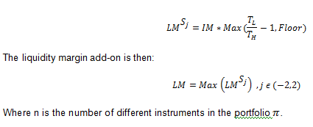

### Example

Below is an example of Liquidity margin add-on using 5 scenarios.

This example is constructed using a virtual portfolio on short sterling options.

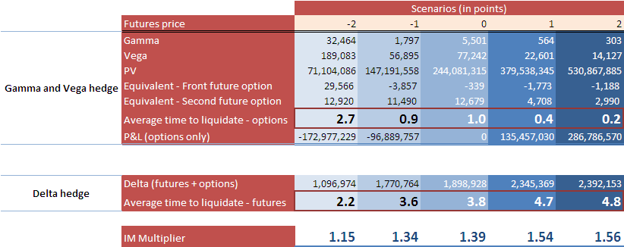

### Independent Validation

The Independent Validation states:

**Liquidity add-on** The liquidity add-on is validated.

**Recommendation (low)**

To clarify what happens in case of very low liquidity. To replace the 1Y daily average for the computation of the AD indicators by a more prudent statistics, like a quantile of the daily traded average distributions

# Pricing Data / Assumptions

As demonstrated by the examples in section 2 above, there are a number of static data requirements underlying the various pricing functions detailed therein. The sections below specify the various sources of such data as well as the assumptions made when the required data is unavailable from the available source files.

## STIR Futures

The table below details the static data requirements underlying the pricing function for STIR futures as well as the assumptions made when the required data is unavailable from the available source file.

The relevant source file for the various fields below is called:

GRI.FANDO_POSITIONS_VW_yymmdd

|  |  |  |
| --- | --- | --- |
| **Contract Attribute** | **Specific Field** | **Assumption(s)** |
| Name / Reference | REFERENCE | - |
| Contract Type | LOGICAL_COMMODITY_CODE | - |
| Currency | TRADING_CURRENCY | - |
| Lot Size | LOT_SIZE | - |
| Tick Denomination | - | 200 for EBR contracts  100 for STL contracts |
| Business Day(s) | - | TARGET for EUR contracts  London for GBP contracts |
| Business Day Conv. | - | Modified Following |
| Expiry Date | LAST_TRADING_DATE | - |
| Deposit Period | MATURITY_PERIOD | - |
| Deposit Start Date | - | Expiry Date + 2 bus. days for EBR contracts  Expiry Date + 0 bus. days for STL contracts |
| Deposit End Date | - | Deposit Start Date + MATURITY_PERIOD |
| Contract Day Basis | - | Actual/360 for EUR contracts  Actual/365 for GBP contracts |
| Index Curve | - | EUR CASH for EUR contracts  GBP CASH for GBP contracts |
| Actual Closing Price | PRICE_VALUE | - |

It should be noted that the current implementation of the NLX HVAR model assumes that ***all*** STIR futures contracts have a deposit period of 90 days. This is of course incorrect as all such contracts are based on a 3-month deposit, the period of which is generally ***not*** precisely 90 days in length.

## Government Bond Futures

The table below details the static data requirements underlying the pricing function for government bond futures as well as the assumptions made when the required data is unavailable from the available source file.

The relevant source file for the various fields below is called:

GRI.FANDO_BONDPOSITIONS_VW_yymmdd

|  |  |  |
| --- | --- | --- |
| **Contract Attribute** | **Specific Field** | **Assumption(s)** |
| Name / Reference | REFERENCE | - |
| Contract Type | LOGICAL_COMMODITY_CODE | - |
| Currency | TRADING_CURRENCY | - |
| Lot Size | LOT_SIZE | - |
| Tick Denomination | - | 200 for SCH contracts  100 for LGT, BOB and BUN contracts |
| Business Day(s) | - | TARGET for EUR contracts  London for GBP contracts |
| Business Day Conv. | - | Modified Following |
| Expiry Date | LAST_TRADING_DATE | - |
| Delivery Date | LAST_TRADING_DATE | - |
| CTD Coupon Rate | COUPON_RATE | - |
| CTD Maturity Date | MATURITY_DATE | - |
| CTD Business Day(s) | - | TARGET for EUR bonds  London for GBP bonds |
| CTD Business Day Conv. | - | Modified Following |
| CTD Settlement Date | - | T+3 for EUR bonds  T+1 for GBP bonds |
| CTD Conversion Factor | CTD_CONV_FACTOR | - |
| CTD Coupon Frequency | PAY_FREQ_PERIOD  PAY_FREQ_MULTIPLIER | - |
| CTD Coupon Day Basis | - | Actual/Actual |
| CTD Clean Quoted Price | BOND_PRICE | - |
| Repo Rate | IMP_REPO_RATE | - |
| Discount Curve | - | EUR BOND DE I016 for EUR bonds  GBP BOND GB I022 for GBP bonds |
| Actual Closing Price | PRICE_VALUE | - |

As noted in section 2.2.1 above, each government bond future’s delivery date (i.e. as defined by the LAST_TRADING_DATE field) is initially set to the latest date permitted under the terms of the relevant product specification and can be moved forward in time in order to accommodate late / overdue deliveries should the need arise.

It should also be noted that although the government bond future pricing function (i.e. as defined in section 2.2 above) is not dependent on an expiry date per se, it is nevertheless necessary to assign such a date for completeness purposes. This follows from the fact – even though it isn’t used in the subsequent calculation itself – the technological implementation of the pricing function includes expiry date as one of its expected input fields.

In addition, notionally setting the expiry date equal to the (last possible) delivery date ensures that the aforementioned pricing function doesn’t fail in the period between the two, during which it may still be necessary to generate one or more contract-level P&L vectors in order to facilitate the calculation of delivery margin for a sub-portfolio of tendered positions in accordance with section 2.2.2 above.

## Options on STIR Futures

In addition to the pricing data that relate to the underlying futures themselves (i.e. as detailed in section 4.1 above), there are a number of additional static data requirements underlying the pricing function for options on STIR futures. The table below specifies the various sources of such data as well as the assumptions made when the required data is unavailable from the available source file.

The relevant source file for the various fields below is called:

GRI.FANDO_POSITIONS_VW(OPTIONS)_yymmdd

|  |  |  |
| --- | --- | --- |
| **Contract Attribute** | **Specific Field** | **Assumption(s)** |
| Name / Reference | DERIV_INSTRUMENT_LCH_ID | - |
| Option Series | LOGICAL_COMMODITY_CODE | - |
| Currency | TRADING_CURRENCY | - |
| Option Strike | STRIKE_PRICE | - |
| Option Type (i.e. Call / Put) | OPTION_TYPE | - |
| Lot Size | LOT_SIZE | - |
| Tick Denomination | - | 200 for all contracts |
| Expiry Date | LAST_TRADING_DATE | - |
| Underlying Future – Name / Reference | LCH_ID | - |
| Underlying Future – Contract Type | UL_LOGICAL_COMMODITY_CODE | - |
| Underlying Future – Expiry Date | UL_LAST_TRADING DATE | - |
| Actual Closing Price | *To be confirmed* | - |

It should be noted that for any particular STIR future option, either LCH_ID ***or*** the combination of UL_LOGICAL_COMMODITY_CODE and UL_LAST_TRADING DATE is sufficient to identify the underlying future itself.

## Options on Government Bond Futures

Similarly, there are a number of additional static data requirements (i.e. over and above those relating to the underlying futures themselves, as detailed in section 4.2 above) underlying the pricing function for options on government bond futures. The table below specifies the various sources of such data as well as the assumptions made when the required data is unavailable from the available source file.

The relevant source file for the various fields below is called:

GRI.FANDO_BONDPOSITIONS_VW(OPTIONS)_yymmdd

|  |  |  |
| --- | --- | --- |
| **Contract Attribute** | **Specific Field** | **Assumption(s)** |
| Name / Reference | DERIV_INSTRUMENT_LCH_ID | - |
| Option Series | LOGICAL_COMMODITY_CODE | - |
| Currency | TRADING_CURRENCY | - |
| Option Strike | STRIKE_PRICE | - |
| Option Type (i.e. Call / Put) | OPTION_TYPE | - |
| Lot Size | LOT_SIZE | - |
| Tick Denomination | - | 200 for SCH contracts  100 for BOB, BUN and LGT contracts |
| Expiry Date | LAST_TRADING_DATE | - |
| Underlying Future – Name / Reference | LCH_ID | - |
| Underlying Future – Contract Type | UL_LOGICAL_COMMODITY_CODE | - |
| Underlying Future – Expiry Date | UL_LAST_TRADING DATE | - |
| Actual Closing Price | *To be confirmed* | - |

As above, it should be noted that for any particular government bond future option, either LCH_ID ***or*** the combination of UL_LOGICAL_COMMODITY_CODE and UL_LAST_TRADING DATE is sufficient to identify the underlying future itself.

# Default Management Process

## Interaction with portfolio margining

SwapClear and Listed Rates are launching a portfolio margining service whereby certain listed rates contracts will become eligible for transfer from a member/client’s listed rates account (‘listed margin class’) to their SwapClear account (‘OTC margin class’) if it is beneficial to do so from a risk/margin reduction standpoint. Listed options will not be eligible for transfer, however the risk profile on listed option positions will be taken into account in the calculation which determines which listed rates contracts to transfer. The SwapClear and Listed Rates default funds are also being merged as part of this proposal.

Once the portfolio margining project is live, there will be a single *integrated* DMG operating across both the OTC Rates and Listed Rates margin classes. This will be formed from the legacy SwapClear and Listed Rates DMGs. The Rates Derivatives DMG will operate in a consultative capacity during the DMP, in particular providing impartial expertise during the process of risk neutralisation and advising on the composition of auction portfolios. The DMG will also execute such trades necessary to neutralise the risk in the defaulted portfolio.

The DMG will operate within the wider default management framework, with the Head of Business Risk for the combined Rates Derivatives service acting as chairman thereof and representing the service in its dealings with the wider group.

It should be noted that where a particular default impacts the Listed Rates margin class only, the external DMG above will *not* normally be mobilised, although LCH.Clearnet Group Limited (LCH.C) will reserve the right to do so should the need arise. In general a default affecting the Listed Rates margin class alone will be risk managed internally using resources and expertise analogous to those within the existing Listed Rates DMG. In such cases we anticipate hedging to be primarily through brokers with whom we currently have Execution Broker Agreements, who will be contacted with a request to execute the proposed hedge trades.

## Management information

SwapClear will perform a full analysis on the defaulter’s portfolio of positions to present in the DMG Pack, including the following information:

* Summary of current positions in the defaulter’s portfolio
* Risk position view of the defaulter’s portfolio in terms of market risk factor sensitivities, i.e. delta ladders by currency and by instrument down to detailed level
* Risk position view of the defaulter’s portfolio in equivalent terms of the eligible instruments across associated exchanges

## Determination of close-out strategy

Upon review of the available trading and risk reports that comprise the DMP Pack and financial management information, the DMG – in consultation with the Head of SwapClear and SwapClear Head of Business Risk - will formulate a hedge strategy which will be presented to the entity CRO for approval. The DMG will then allocate / delegate responsibility for the various components of the hedge strategy, and execute the hedge strategy / trades on behalf of the clearinghouse in the name of the relevant LCH.Clearnet CCP.

# Back-testing of Initial Margin

The SwapClear Quantitative Analytics team carried out comprehensive model analyses to assess a suitable Initial Margin model for Listed Options.

Backtesting was performed on the current NLX IM model (IMv2) as well as a number of variations where different scaling methodologies and lambda were used.

Results have shown that IMv2 (the current NLX model) on average produces IM that does not exhibit a high degree of pro-cyclicality, but has consistent business backtesting, Kupiec passes and IM statistical measures.

Based on backtesting and analysis performed on contracts, strategies (call spreads, butterflies and straddles), hedged portfolios and hypothetical portfolios on historical and stress data scenarios (Lehman period), SwapClear Quantitative Analytics recommends margining of Listed Options using the existing initial margin model, IMv2.

The reasons for this recommendation are the following:

* Statistical results show that the model behaves as expected under several conditions, including stressed periods.
* The model does not exhibit a high degree of pro-cyclicality, compared to the alternatives considered.
* It provides a consistent framework across all other cleared products by SwapClear.

## Scope and Approach

The scope for SwapClear’s proposed margining is as follows:

* Government Bond Futures Options: options on Euro-Schatz Futures, Euro-Bobl Futures and Euro-Bund Futures.
* STIRs Futures Mid-Curve Options: 1y, 2y, 3y and 4y Mid-Curve Options on 3-Month EURIBOR Futures and on -Month Short Sterling Futures.
* STIRs Futures Options: Options on 3-Month EURIBOR Futures and 3-Month Short Sterling Futures.

The approach used in the model analysis was to perform several tests, namely the Kupiec test, where IM is based on non-overlapping one day returns and compared to one day PnLs, business backtesting where confidence plots and IM vs PnL plots based on 2 days overlapping returns, statistical measures such as average IM, number and size of breaches and Bank of England Procyclicality measures.

Several different initial margining models were evaluated and tested during the development of the SwapClear Initial Margin model for Listed Options. The following table summarizes the parameters of the models evaluated, and the following section describes these in more details.

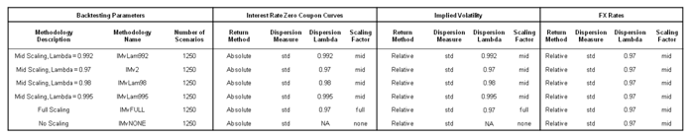

## Market Data and Portfolios

The Time Series used in the backtesting were as follows:

* Historical zero coupon rates: Existing SwapClear FX data, zero coupon Government Bond curves, STIRs zero coupon curves
* Historical market prices of options: market prices of options used to bootstrap daily volatility surfaces
* Simulated Historical time series: Lehman Repeat data

The Portfolios used in each backtesting case were:

* Contract level (using both real and theoretical contracts, on various expiries and money-ness levels)
* Intra currency strategies (call spreads, butterflies and straddles)
* Hypothetical Portfolios (Hedged portfolios, Cross-product Portfolios) [note that cross-product portfolio analysis and hedge portfolios on mid-curves is still being carried out]

## Results

Summary tables of the Average Business Confidence for each combination of portfolio and time series considered in the backtesting are displayed below. For each backtesting case, business confidence is defined as:

Business Confidence = 1 – (Number of Breaches of IM)/(Number of Observations)

The green colour indicates that the average business confidence is above the 99.7% risk appetite of LCH.Clearnet and the yellow colour indicates that it is below this threshold.

The majority of the backtesting cases were tested comfortably above the 99.7% standard. As can be seen in the table below, outliers occurred for the specific strategies where the portfolio is exposed to the non ATM volatility. Further investigation is being carried out on add-ons for the risks not included in the core IM model.

The long out of the money contracts were excluded from the results due to many very small breaches experienced on very small IM. To avoid these breaches our tests showed that the IM methodology needs to mark the starting option price for each scenarios back to market option price.









The Kupiec test performance for all combinations of time series and portfolios was also in the majority of cases “Pass”. As in the business backtesting, majority outliers occurred for specific strategies where the portfolio is exposed to the non ATM volatility.

## Conclusion

SwapClear conclude that based on the extensive backtesting and analysis performed that the current initial margin model is suitable.

Analysis shows that the model predominantly behaves in line with LCH risk appetite. Further investigation is being carried out to consider add-ons to cover risk not in VaR.

## Independent Validation

The Independent Validation states:

**Historical VaR**

The Historical VaR methodology is validated.

The choice of a slice SSVI model is a very good choice in the context of NLX options where few quotes

are available per slice. Also the implied ATM volatility is a model parameter in the slice SSVI model, so it is automatically fitted and there will be no calibration noise at the level of the key risk factor for the HVaR

procedure.

**Recommendation (low)**

It is recommended to investigate the usage of interpolation of the slice SSVI models in the model param-

eters space, which is expected to simplify and robustify the double bilinear interpolation plus adjustment

procedure. Moreover it would make the HVaR model more consistent with the model used in the Model

Add-on.

# Model Add-ons

In this section we will lay down the specifications for the model add-on due to risk not captured in the core IM which has been identified as follows. The total add-on will be the total contribution of both components

* Dynamics in the volatility smile not captured by the relative shift of ATM volatilities in the IM model, eg. Skew and vol of vol.
* Aging of the option portfolios: Theta

The following sections provide a mathematical framework to conservatively estimate the required additional resources to IM in order to capture those risks not in the model.

## Volatility Model

The natural SVI model has been assumed during this project an accurate model to described the options volatility smiles and surfaces, then the core IM is only accounting for relative changes in the ATM vol (or equivalently ) while keeping (skew) and (vol of vol) constant. As a result an add-on is required to account for these missing risk factors

(1)

By definition the total variance is defined as, where is the lognormal volatility and is the option’s time to expiry in annual basis.

(2)

Empirically it has been shown that is a function dependent on . For example the surface SVI (SSVI) parametric function below for seems to be consistent with the empirically observed term structure of the volatility.

Following some observed results, has been assumed to be equal to 0.5 and since interest rate volatilities are normally low, the previous parameterisation can be simplified as follows.

(3)

## Volatility Add-on

A simple approach to measure the potential impact of changes in skew and vol of vol in the IM model is by estimating the effect on the contract price by shifting those parameters to some calibrated extreme moves.

and

Mathematically this can be achieved by directly multiplying the contract Vega (Black representation) by the relevant derivatives following the chain rule. The following two formulas present the definition of the two main components of the volatility add-on.

(4)

(5)

Where and are the contract Vega and volatility respectively, while and and are the 2-day extreme shifts in and which are calibrated from historical data.

### Linear effect of

In order to solve equation (3), the following expressions are derived from equation (1) and (2).

Finally by combining all the relevant formulas, the add-on is defined as.

(6)

### Linear effect of

Similarly, the effect on changes in is estimated from the following equations.

(7)

Equations (6) and (7) describe the potential p&l effect on a given contract due to changes in and respectively. The last part is to provide a framework to estimate the extreme shifts in and .

### and extreme shifts

A well known and robust approach to estimate extreme but plausible parameter shifts is by directly multiplying a calibrated standard deviation of the parameter returns by a quantile for a given probability threshold, the benefit of this approach is that the business has the ability to increase, if needed, the size of the add-on by simply increasing the quantile level.

The formula below presents the proposed framework to estimate extreme shifts in .

E.g. if a normal distribution is assumed with a probability of 99%, the quantile .

Similarly uses the same approach, however as the total changes in can be attributed to changes in and as defined in equation (3) and remembering that the core IM only considers changes in the vol in the first term on equation (1) the extreme shift is approximated as the linear contribution to extreme shifts in and .

(8)

(9)

### Calibrations

Calibration of the Add-on parameters such as the SVI parameters and respective standard deviations, are directly obtained from the mean and the standard deviation of the 2-day returns of actual SVI calibrations from historical data. Below are the values obtained for each contract.

|  |  |  |
| --- | --- | --- |
| Contract | ρMean | ηMean |
| Schatz | -0.1536 | 0.5302433 |
| Bobl | -0.2035 | 0.4445285 |
| Bund | -0.119 | 0.4241529 |
| EUR STIRS | -0.3818 | 0.8085619 |
| GBP STIRS | -0.3774 | 0.768116 |
| EUR 1Y Mid Curve | -0.45818 | 0.576123 |
| GBP 1Y Mid Curve | -0.47272 | 0.564212 |

|  |  |  |  |
| --- | --- | --- | --- |
| Contract | sdρ | sdη | sdv |
| Schatz | 0.1192077 | 0.1303496 |  |
| Bobl | 0.08231465 | 0.08229 | User defined  (e.g sd, quantile, max, etc) |
| Bund | 0.07421793 | 0.06851502 |  |
| EUR STIRS | 0.1080094 | 0.1195193 |  |
| GBP STIRS | 0.097057 | 0.089741 |  |
| EUR 1y Mid Curve | 0.1174233 | 0.072223 |  |
| GBP 1y Mid Curve | 0.1126546 | 0.067541 |  |

## Volatility add-on scenarios

As previous framework splits the contributions from skew and vol of vol to core IM, 4 individual scenarios are generated as a result: up, down, up and down which can be combined to produce 4 more scenarios.

In order to avoid creating an overly conservative combined scenario, if changes in and are assumed to be independent, these scenarios can be implied from the intermediate points in the isoquantile ellipse using the following formulas.

|  |  |  |  |
| --- | --- | --- | --- |
| Core Scenarios | | Combined Scenarios | |
| Scenario 1 |  | Scenario 5 |  |
| Scenario 2 |  | Scenario 6 |  |
| Scenario 3 |  | Scenario 7 |  |
| Scenario 4 |  | Scenario 8 |  |

For each contract in the portfolio, all 8 scenarios are calculated and aggregated at a scenario level. The total add-on will be the scenario that produces the worst p&l for the portfolio.

## Theta Add-on

In order to capture the p&l effect of the contracts and portfolio aging, the net theta will be conservatively multiplied by 4 days as this represents the 2 business day holding period observed over a weekend. The theta add-on will only be considered when it increases the potential loss in the portfolio.

The following formula shows the mathematical representation of the theta add-on.

## Add-on Analysis and Results

In order to test the add-on methodology, more than 500 portfolios per contract (Schatz, Bobl and Bund) covering a wide range of strategies including call, put, call spread, straddles, strangles, risk reversals and butterflies and several expiries ranging from 15 to 120 days were tested with and without the add-on in order to compare its effectiveness.

Below is a summary table with the aggregated business confidence level for each strategy and contract tested using a hypothetical model.

The results clearly show the effectiveness of the add-on by keeping the average confidence level above SwapClear 99.7% risk appetite for those strategies were nonlinear changes in the volatility surface can be considered the main contributors to p&l’s such as butterflies, straddles and strangles.





Similarly an equivalent test was also performed by using the actual and more complex backtesting model generating comparable results as shown in the following table.

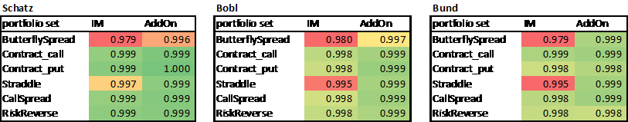



## Independent Validation

The Independent Validation states:

*2.2 Model Add-On*

*2.2.1 Validation (high)*

*The Model Add-On is validated.*

*The choice of SSVI is a very good choice for this purpose.*

*2.2.2 Recommendation (low)*

*The shocks are computed from an history of calibrated SSVI parameters, yet there is no guarantee that the calibration works well, due to the fact that and are global constants. The value of the optimal objective function could be recorded altogether with the calibrated parameters, and those weights could be used in the selection of historical shocks. More precisely, it could occur that a significant historical move of and/or in market data is not captured due to an erroneous calibration. In that case, the recorded historical variation will underestimate the real historical move, so less importance should be given to it in the selection of the corresponding parameter variations.*

# Stress Testing

In order to stress the Volatility surface we choose to calibrate a natural – SVI model. We choose this model due to its simplicity and consistency with the Skew Add-on Initial Margin model for ETOs. Further detail on the SVI model is included in the appendix of this document.

## Preliminary analysis

Principal Components Analysis (PCA) was used in order to extract the main factors driving changes in the Volatility surface. 95% of the variation can cumulatively be explained by considering the first 3 factors for all products and expiry tenors. This is illustrated in Appendix 3, Figure1.

These factors corresponded (in order of size) to, level of Volatility (or ATM Volatility), steepness of the skew and curvature. These have a close relationship to the parameters that we mentioned above.

## Methodology – Historical ATM Options

Many different types of volatilities are quoted in the market. The most commonly used relative measure for interest rate volatility is Basis Point (BP) / Normalised volatility. Lognormal Yield Volatility can be converted to a BP Volatility by the following formula:

BP Volatility = Yield Volatility (%) x Forward Yield (%)

The rationale to use this measure of volatility rather than the conventional Black-Scholes Yield Volatility is that it is independent / uncorrelated to the level of the underlying asset. The stresses for Bond Futures and STIRs as the underlying assets have already been calculated, therefore, it is important to find a level independent measure of volatility to avoid double counting. The difference is graphed in Appendix 3, Figures 2 & 3. If the volatility output is already Normal such as in the case of STIR options then nothing needs to be done.

Using this measure it is straightforward to locate the largest changes in ATM volatility over our time series of observations. For each product and expiry we compute the maximum and minimum stresses in volatility over a 5-day holding period. As we noted above, ATM-volatility explains a large portion of the variance of the changes in the surface over time and also, ATM options have the largest exposure to volatility (Vega). For completeness, we also add on the corresponding changes in the forward and skew parameters ρ and ϕ too, allowing us to re-create a fully stressed volatility surface using historical data.

## Results – ATM

The maximum changes in ATM volatility in the bond options, STIRs and mid-curves market occurred during the time of Lehman Brothers bankruptcy and amidst the Euro-Zone crisis in 2011. Results for the European Bond Options are shown in Appendix 3, Figure 4.

## Methodology – Theoretical

In order to supplement our suite of Historical scenarios, we consider various theoretical scenarios, which fall into one of the categories below:

1. Antithetic to our existing Historical scenarios
2. De-correlated to what happens in a normal market
3. Segregating exposure to a risk factor

1. Antithetic Scenarios:   
In the suite of Historical scenarios, if we have a large positive shock to ATM volatility and no equally negative shock, we add a scenario which is antithetic to the large positive shock and vice versa.

2. De-correlated:   
We considered many scenarios which are de-correlated from ordinary market behaviour.

- When volatility increases the term-structure of volatility usually flattens (i.e. shorter expiries increase more in volatility terms than longer expiries) and when volatility decreases the term structure steepens. This is a well observed empirical fact and is called the “Square Root of Time” rule. As a rule of thumb, if 3m expiries increase by 40bp this implies 1y expiries increase by only 20bp. We break this correlation by inverting the term structure.

- EUR & GBP ATM-volatility tends to be correlated reasonably strongly for STIRS. The rationale is that Monetary Policy for these economies also tends to be positively correlated. We add theoretical scenarios with the maximum positive observed Historical EUR-STIR ATM-volatility and minimum negative observed Historical GBP-STIR ATM-volatility, and vice versa.

3. Segregation:   
As we noted, the shape of the skew is governed by both ρ and ϕ and further the absolute size of ϕ also controls curvature. Therefore, it is more accurate to stress the risk factors from the PCA analysis conducted, as this takes into account all the various dynamics. We compute scenarios by taking each factors loading (eigenvector) and multiply it by its maximum/minimum score to create a theoretically stressed scenario where one risk factor is moving independently from all others. Appendix 6, Figure 5 has an example of what we propose. As the Historical, antithetic and de-correlation scenarios are comprehensive for ATM-volatility we don’t repeat the analysis here for Factor 1 (ATM-volatility).

For each of the above, we also add a corresponding change in the forward rate/prices.

## Proposed scenarios

From the analysis above, 20 of the historical scenarios we propose exist in the current stress testing data base already. The relevant risk factors (in this case volatility and the associated parameters) will be added to these accordingly.

To supplement these 20 historical scenarios, we propose an additional 23 new scenarios. The breakdown is as follows:

* 2 historical scenarios not in the current suite of stress scenarios
* 3 Antithetic scenarios
* 6 De-correlation scenarios
* 12 Segregation scenarios

## Testing

The proposed stress scenarios were tested using various hypothetical trading strategies. The implied loss from the worst stress scenario for a particular strategy was compared to the Initial Margin and more extreme events occurring (probabilistically) once in 10 and 30 years. The stress scenarios were found to be more conservative in all cases. These results are available upon request. Figure 6, 7, 8 and 9 in Appendix 3 illustrate some of the results.

## Independent Validation

The Independent Validation states:

**Stress Testing**

The stress testing framework is validated.

The generated stress tests are a mix of historical and theoretical scenarios, where the worst observed moves are used, in addition to specific shifts to account for a possible decorrelation and the effect of the volatility skew and curvature.

# Reporting

As well as producing GBP-denominated P&L vectors by contract (which are contained in the varlosses.csv output file), the NLX HVAR model also needs to be able to satisfy various other reporting and analytical requirements as part of the overall service. These are outlined below.

## 

## Theoretical Prices vs. Actual Prices

At the heart of the NLX HVAR model are a number of pricing functions that – between them – generate a current theoretical price for each contract. As described in section 1.9 above, these current prices act as the zero-P&L reference points for the subsequent HVAR simulation.

In order to check that these functions are performing correctly and generating accurate prices, a daily comparison of theoretical and actual (exchange) prices should be undertaken.

On any particular evaluation date, a suitable report to facilitate such an exercise might look as follows:

|  |  |  |  |
| --- | --- | --- | --- |
| **Contract Reference** | **Theoretical Price** | **Actual Price** | **Difference (%)** |
| F-NLX-FUT-NINI-20140300 | 99.7250 | 99.7400 | -0.02% |
| F-NLX-FUT-NINI-20140400 | 99.7400 | 99.7450 | -0.01% |
| F-NLX-FUT-NINI-20140500 | 99.7700 | 99.7600 | +0.01% |
| F-NLX-FUT-NINI-20140600 | 99.7700 | 99.7600 | +0.01% |
| F-NLX-FUT-NINI-20140700 | 99.7650 | 99.7450 | +0.02% |
| F-NLX-FUT-NINI-20140900 | 99.7500 | 99.7550 | -0.01% |
| …… | …… | …… | …… |

The theoretical price of each contract is included in the “results.csv” file.

## 

## Cheapest-to-Deliver Bond Spreads

As detailed in section 2.2 above, one of the key parts of the pricing function for government bond futures is the calculation of a theoretical clean price for each underlying CTD bond. This involves deriving the flat spread over / under the sovereign discount curve, as implied by the CTD’s actual clean price.

In order to check that this particular part of the pricing function is performing correctly, a daily review of these implied spreads should be undertaken.

On any particular close-of-business date, a suitable report to facilitate such an exercise might look as follows:

|  |  |  |
| --- | --- | --- |
| **Contract Reference** | **Underlying CTD** | **CTD Spread (bp)** |
| F-NLX-FUT-NSNS-20140300 | DE0001137446 | -0.7262 |
| F-NLX-FUT-NSNS-20140600 | DE0001141604 | -1.9851 |
| F-NLX-FUT-NSNS-20140900 | DE0001135309 | -2.8603 |
| F-NLX-FUT-NUNU-20140300 | DE0001102309 | +0.3493 |
| F-NLX-FUT-NUNU-20140600 | DE0001102309 | +0.3493 |
| F-NLX-FUT-NUNU-20140900 | DE0001102325 | +0.6088 |
| F-NLX-FUT-NRNR-20140300 | GB0030880693 | +1.8946 |
| F-NLX-FUT-NRNR-20140600 | GB0030880693 | +1.8946 |
| F-NLX-FUT-NRNR-20140900 | GB0030880693 | +1.8946 |
| …… | …… | …… |

The CTD spread for each government bond future contract (expressed in absolute terms) is included in the “results.csv” file.

## Sensitivity Analysis

For risk management purposes, it is also a requirement for the NLX HVAR model to generate a range of sensitivity measures for each contract as follows:

* Zero-rate PV01 ladder for each STIR futures contract;
* Zero-rate PV01 ladder for each government bond futures contract;
* Repo rate PV01 for each government bond futures contract;
* Delta-weighted zero-rate PV01 ladder for each STIR future option contract;
* Expiry-bucketed gamma, vega and theta for each STIR future option contract;
* Delta-weighted zero-rate PV01 ladder for each government bond future option contract;
* Delta-weighted repo rate PV01 for each government bond future option contract; and
* Expiry-bucketed gamma, vega and theta for each government bond future option contract.

All these measures are calculated on a “per lot” basis ***without*** using the price rounding implied by each contract’s underlying tick denomination.

In addition, each PV01 ladder should reference the set of tenor points associated with the relevant underlying curve, as shown in the example below.

The precise formulation of each relevant option-related sensitivity measure (i.e. delta, gamma, vega and theta) is reproduced in Appendix 2.

### Futures PV01 Example

As at 17th February 2014, the PV01 sensitivities (denominated in EUR per lot) for the March and June 2014 EURIBOR futures were as follows:

|  |  |  |
| --- | --- | --- |
| **Risk Factor** | **F-NLX-FUT-NINI-20140300** | **F-NLX-FUT-NINI-20140600** |
| EUR CASH 3M | -14.2694 | +22.2926 |
| EUR CASH 6M | -10.3364 | -28.8884 |
| EUR CASH 9M | +0.0000 | -18.0185 |
| EUR CASH 1Y | +0.0000 | +0.0000 |
| …… | …… | …… |

It should be noted that these particular futures have no sensitivity to zero-coupon index rates beyond the 9-month point. Hence, the zero “per lot” sensitivities to this section of the relevant underlying curve (EUR CASH) have not been reproduced in the table above.

The zero-rate PV01 ladder for each contract is contained in the “bktDelta.csv” file.

In addition, the total “parallel shift” PV01 for each contract – classified according to broad sensitivity type i.e. PV01 (Disc), PV01 (Index) and PV01 (Repo) – is included in the “results.csv” file.

For each relevant contract, the same “results.csv” file also contains the option-related sensitivity measures detailed above.

# Operational Procedures

This is covered in full in the following document:





Appendix 1 – Fitted Volatility Smile Model

The FVS model is based on the Stochastic Volatility Inspired (SVI) model developed by J. Gatheral and provides an efficient and robust method for parameterising implied volatility curves (at each expiry tenor) across a variety of options types.

Model Formulation

For a given option series and expiry tenor, the FVS model is parameterised by minimising the sum of the squared errors between the market prices and the FVS-modelled prices across all available option strikes, as follows:

where

* is the total number of available strikes
* is the squared error in price for the strike
* is the market price for the strike
* is the FVS modelled price for the strike where

  + is the ATM volatility
  + is the time to maturity
  + is the underlying forward
  + is the strike

The squared error minimisation is performed using Levenberg-Marquardt algorithm.

Market Data

The FVS model is used in conjunction with market data that takes the following form:

|  |  |  |  |  |  |  |
| --- | --- | --- | --- | --- | --- | --- |
| **Option Series** | **Date** | **Time to Expiry** | **Forward** | **Strike** | **Log-Normal Volatility %** | **Call Price** |
| Euro-Schatz | 20131108 | 0.115068 | 110.53 | 110.10 | 0.8054 | 0.4404 |
| Euro-Schatz | 20131108 | 0.115068 | 110.53 | 110.20 | 0.7642 | 0.3476 |
| Euro-Schatz | 20131108 | 0.115068 | 110.53 | 110.30 | 0.7228 | 0.2598 |
| Euro-Schatz | 20131108 | 0.115068 | 110.53 | 110.40 | 0.6832 | 0.1800 |
| Euro-Schatz | 20131108 | 0.115068 | 110.53 | 110.50 | 0.6522 | 0.1133 |
| Euro-Schatz | 20131108 | 0.115068 | 110.53 | 110.60 | 0.6413 | 0.0650 |

Example of FVS Parameterisation

In order to demonstrate how the parameterisation of the FVS model works in practice, the following market data from June 12, 2014 (for options on the Euro-Schatz futures contract, expiring in 162 days) was used:

|  |  |  |  |  |  |  |
| --- | --- | --- | --- | --- | --- | --- |
| **Option Series** | **Date** | **Time to Expiry** | **Forward** | **Strike** | **Log-Normal Volatility %** | **Call Price** |
| Euro-Schatz | 20140612 | 0.443836 | 110.675 | 109.90 | 0.5650 | 0.780 |
| Euro-Schatz | 20140612 | 0.443836 | 110.675 | 110.00 | 0.5039 | 0.680 |
| Euro-Schatz | 20140612 | 0.443836 | 110.675 | 110.10 | 0.4417 | 0.580 |
| Euro-Schatz | 20140612 | 0.443836 | 110.675 | 110.20 | 0.4378 | 0.485 |
| Euro-Schatz | 20140612 | 0.443836 | 110.675 | 110.30 | 0.4413 | 0.395 |
| Euro-Schatz | 20140612 | 0.443836 | 110.675 | 110.40 | 0.4114 | 0.305 |
| Euro-Schatz | 20140612 | 0.443836 | 110.675 | 110.50 | 0.3991 | 0.225 |
| Euro-Schatz | 20140612 | 0.443836 | 110.675 | 110.60 | 0.4038 | 0.160 |
| Euro-Schatz | 20140612 | 0.443836 | 110.675 | 110.70 | 0.3980 | 0.105 |
| Euro-Schatz | 20140612 | 0.443836 | 110.675 | 110.80 | 0.3976 | 0.065 |
| Euro-Schatz | 20140612 | 0.443836 | 110.675 | 110.90 | 0.3866 | 0.035 |
| Euro-Schatz | 20140612 | 0.443836 | 110.675 | 111.00 | 0.3984 | 0.020 |
| Euro-Schatz | 20140612 | 0.443836 | 110.675 | 111.10 | 0.4004 | 0.010 |
| Euro-Schatz | 20140612 | 0.443836 | 110.675 | 111.20 | 0.4082 | 0.005 |
| Euro-Schatz | 20140612 | 0.443836 | 110.675 | 111.30 | 0.4703 | 0.005 |

The sum of the squared errors between the market prices and the FVS-modelled prices across all available option strikes is minimised when the 2 calibration parameters and take the following values:

|  |  |
| --- | --- |
| **Parameter** | **Value** |
|  | -0.1236903 |
|  | 0.5108508 |

is the ATM volatility, 0.3980% in this case.

Given the above parameterisation, the FVS variances and volatility levels are calculated as follows:

|  |  |  |  |
| --- | --- | --- | --- |
| **Strike ()** | **Mkt Prices ()** | **FVS Prices ()** | **Asolute Error ()** |
| 109.90 | 0.780 | 0.777 | 0.003 |
| 110.00 | 0.680 | 0.678 | 0.002 |
| 110.10 | 0.580 | 0.581 | 0.001 |
| 110.20 | 0.485 | 0.486 | 0.001 |
| 110.30 | 0.395 | 0.393 | 0.002 |
| 110.40 | 0.305 | 0.307 | 0.002 |
| 110.50 | 0.225 | 0.228 | 0.003 |
| 110.60 | 0.160 | 0.159 | 0.001 |
| 110.70 | 0.105 | 0.105 | 0.000 |
| 110.80 | 0.065 | 0.064 | 0.001 |
| 110.90 | 0.035 | 0.037 | 0.002 |
| 111.00 | 0.020 | 0.020 | 0.000 |
| 111.10 | 0.010 | 0.011 | 0.001 |
| 111.20 | 0.005 | 0.005 | 0.000 |
| 111.30 | 0.005 | 0.003 | 0.002 |

Appendix 2 – Formulation of Asay Model “Greeks”

As detailed in section 5.3 above, the NLX HVAR model is required to generate a range of sensitivity measures for each contract. These include many of the so-called “Greeks” associated with the Asay-82 option pricing model, as follows:

* Delta

, where

* Gamma

* Vega

, where

* Theta

Appendix 3 – Back-test Results – Options on EURIBOR STIRS – Theoretical ATM contracts.

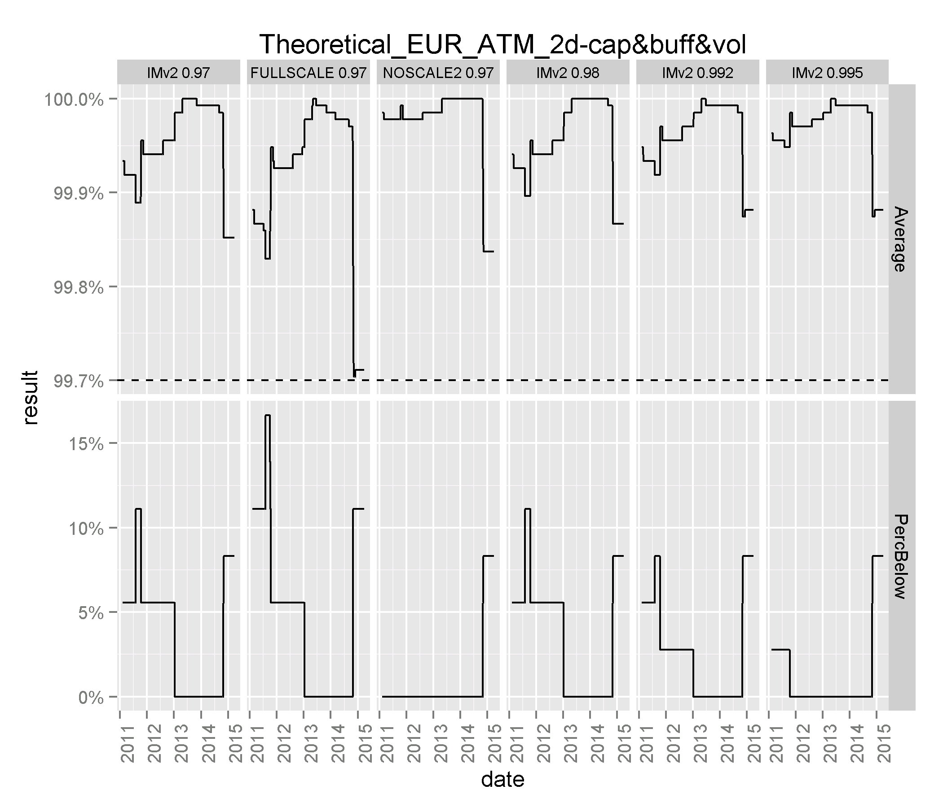

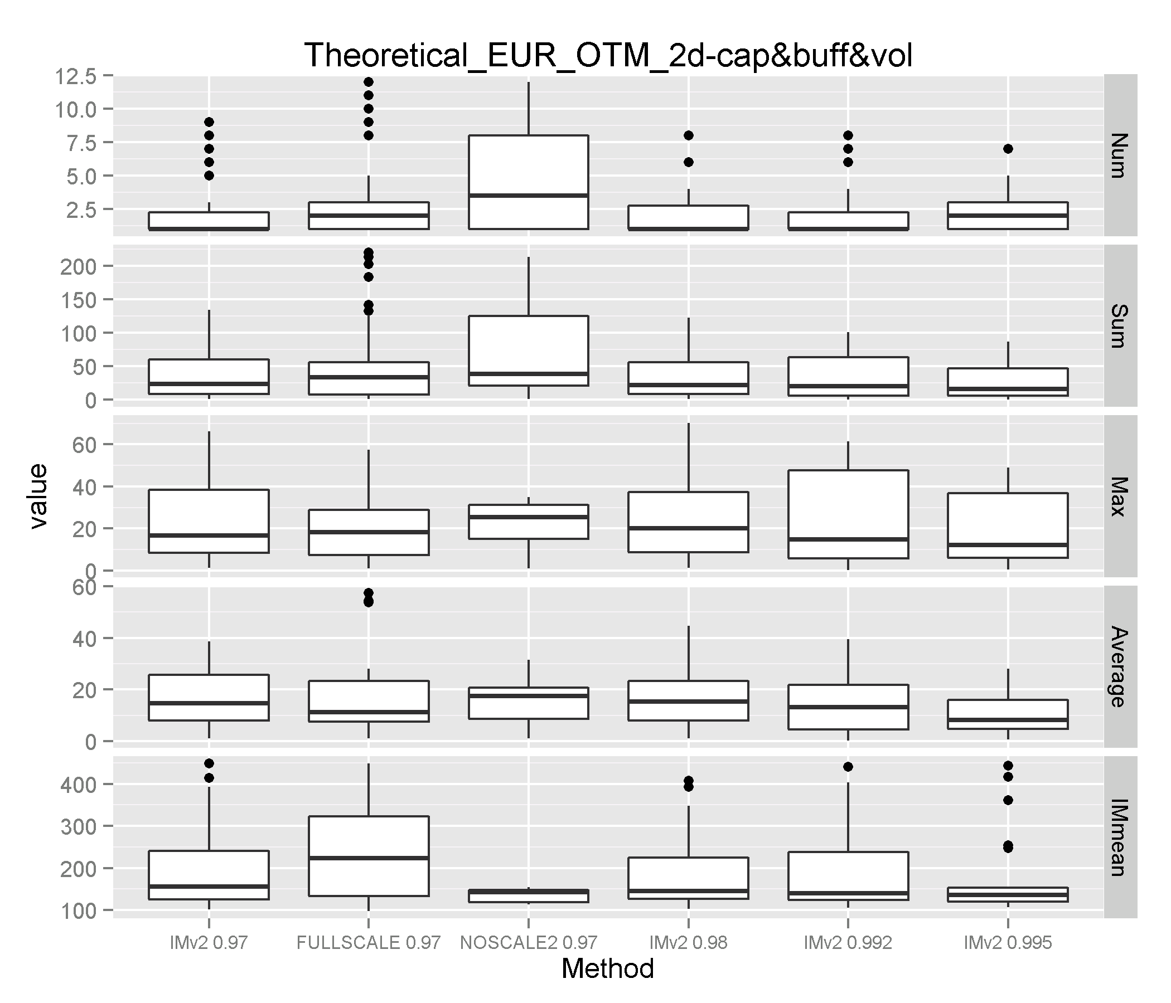

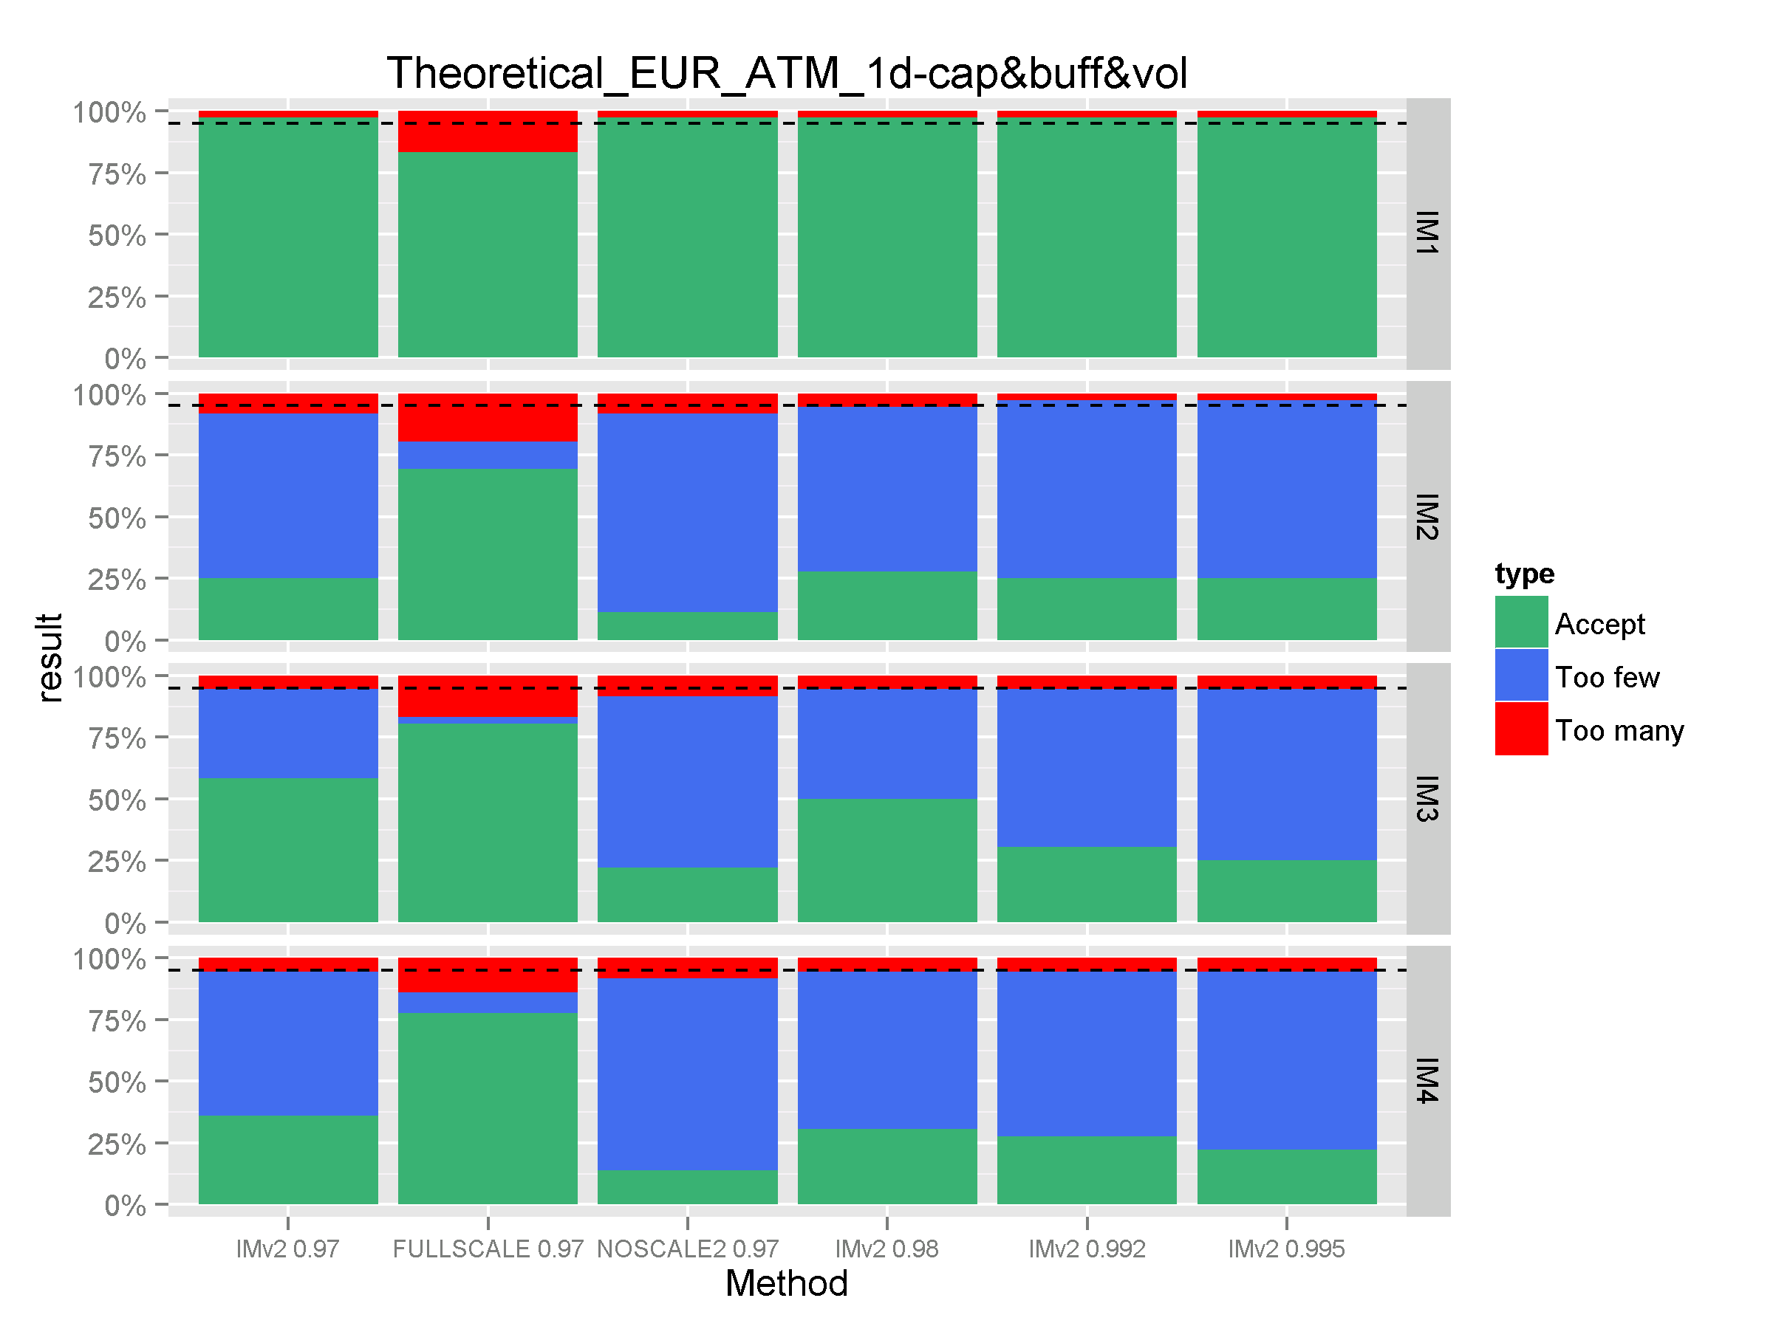

Appendix 4 – Stress Testing Results

**Figure 1:** PCA Loadings for a 30 day Short Sterling Option

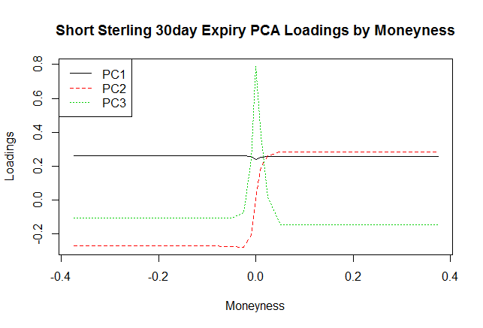  
**Figure 2:** Lognormal Volatility for a 30 day Bobl Option vs. underlying futures price

**Figure 3:** Normal Volatility for a 30 day Bobl Option vs. underlying futures price  
  
**Figure 4:** Example of Schatz Bond Option proposed ATM – stress scenarios







**Figure 5:** Results from the maximum & minimum score of Loading 2 from the PCA analysis

  
  
**Figure 6:** Illustrating the various combinations of forward price and volatility changes from our time series of data (red) along with the stress scenarios (blue) for the 30 day Bund option. The ellipsoids represent the changes in the scope of the Initial margin model (red), “1 in 10y” and “1 in 30y” events (blue). The dots outside the region in blue represent the stress scenario changes.

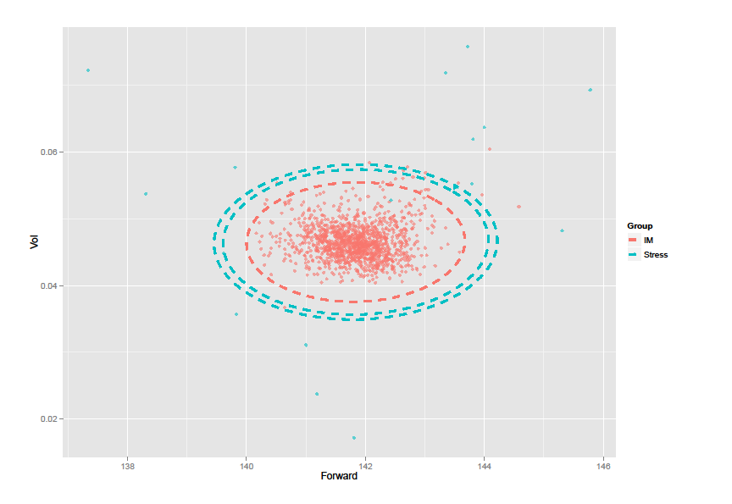

**Figure 7:** The Profit & Loss displayed for a 30 day Bund call option, for various levels of moneyness. The right box plot illustrates the Initial Margin; the left box plot for each moneyness represents the “Extreme” scenarios profit and loss (i.e. the 1 in 10y and 1 in 30y events). The dotted lines below represent where the minimum stress test profit and loss is. Evidently, the stress test is always more conservative.

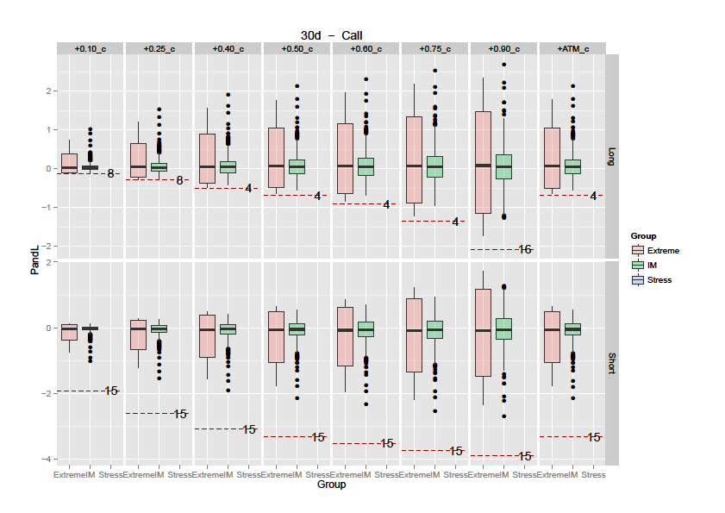**Figure 8:** Similar analysis to above for a call spread

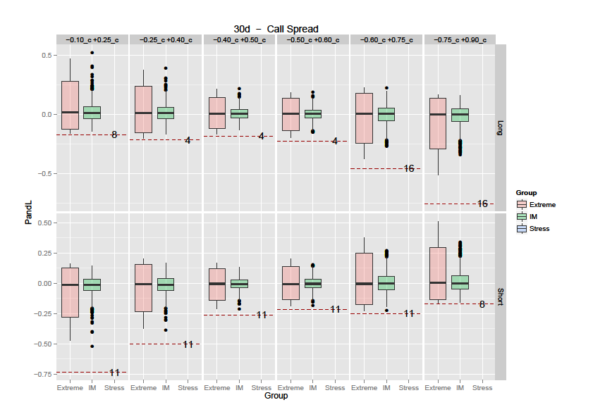

**Figure 9:** Similar analysis to above for a straddle

